VRATE 2022 Program

7:00AM - 8:15AM
Title: What Alexa can do for you.
Presenters:
Lupita Hernandez, CVRT and Fernando Tarazon, VRT - Arizona Center for the Blind and Visually Impaired

Presenters will discuss the different steps in the process of Alexa from installing to having fun with Alexa. First they are going to review how to install the application on your phone and then how to pair it to your device. Next they are going to cover ways to use it. They will review different things that you can do with Alexa from asking directions to playing games. They are also going to use the echo show to describe different products uses at home.

8:30 AM - 9:45 AM
Title The Family Advantage for Success at Work

Presenter – Ron Brooks
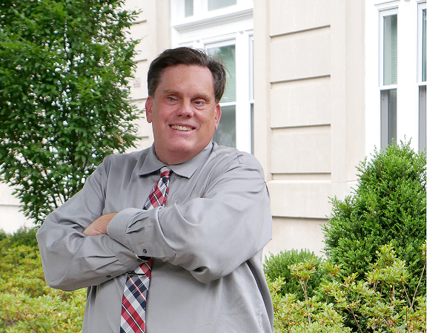
VRATE is all about how to help blind and visually impaired people gain and maintain independence through high-quality rehabilitation services and by using technology. But most days begin and end at home, so having a positive relationship with the family is at least as important as the most sophisticated piece of assistive technology available. Ron Brooks is blind, a graduate of Indiana University and committed to transforming mobility for people with disabilities. In 2020, Ron founded Accessible Avenue to provide accessibility focused consulting and training services to the mobility industries where he has worked for the past 28 years planning and managing accessible transit and paratransit services. . Ron is proud of his work in the transit industry, but he attributes the bulk of his personal and professional success to the support, strength and stability he derives from his relationships at home. During his presentation, Ron will share a bit of his own story and provide some ideas for building family relationships that can stand the test of time and provide a solid foundation for personal and professional success.

10:00 AM - 11:15
Title: Low Vision Rehabilitation for Medical, Employment and BVI Professionals Part 1
Presenter: Carlos Grandela, OD and Karla Rivas Parker, MSW, M. Ed., CRC, CATIS, CVRT Governor’s Council on Blindness AT Committee

This session will review the medical, functional, and vocational implications of low vision assessments and vision rehabilitation therapies. The information is presented in two sessions focusing on medical aspects in Part 1 and how the medical aspects apply to vocational considerations and independence.

11:30 AM- 12:45 PM
Title: Low Vision Rehabilitation for Medical, Employment and BVI Professionals Part 2
Presenter: Carlos Grandela, OD and Karla Rivas Parker, MSW, M. Ed., CRC, CATIS, CVRT Governor’s Council on Blindness AT Committee

Participants will learn how a Clinical Low Vision Evaluation is conducted and how low vision aids and devices can support independence and employment.

1:00 PM – 2:15 PM
Title: How I Transitioned from Working in Academia to Co-creating a Medical/Scientific Communications Company
Presenter: Dean Colston, PhD, MA, A Flock of Scientists, LLC,

Losing one’s vision can be a life-changing event. Dr. Dean Colston shares his personal story of how he left the world of academia after significant vision loss and embarked on a new career in technical communications. The COVID-19 public health emergency reshaped much of our lives, including the communication landscape. It was during the beginning of this pandemic that he put his technical, interpersonal, and virtual communication skills to use by collaborating with three scientists/medical communicators to start A Flock of Scientists, LLC, an organization that provides high-quality scientific writing, editing, and content creation services.

2:30 PM - 3:45 PM
Title: Social Security Disability Benefits for Those With Blindness or Visual Impairments
Presenter: Jack Burns, Social Security Admiration

Jack will discuss the Social Security definition of disability and other eligibility requirements as well as some news, updates on services and the rules on working and receiving benefits. A question and answer session will follow the presentation.

4:00 PM- 5:15 PM
Title: Electronic Resources Accessible Throughout Arizona
Presenters: Christine Tuttle, Outreach Librarian and Mary Villegas, Library Consultant, Arizona State Library, Archives and Public Records

Presenters will discuss electronic resources accessibility at the local, county, and state levels In the time of COVID and what’s next to gain access to these resources either by using an online library card or be a member of the Talking Book Library. Two branches of the state library system; Digital Access Library (DAZL) and Talking Book Library (TBL) presents what information is accessible to Arizona residents and access to materials available on the BARD catalog. Each branch will discuss their resource content, the navigation of each system, and the tools to gain access to these electronic resources.

